Testuojam CNN , Foto dydis 32x32, learning rate 0.005, naudoju Conv2d, Maxpooling, Horizontal flip 0.2, callbacks, testsplit 0.2, foto padaromos nespalvotos, 40 epochu.

981/981 ━━━━━━━━━━━━━━━━━━━━ 15s 15ms/step - accuracy: 0.5993 - loss: 1.1842 - val_accuracy: 0.6697 - val_loss: 0.9658 - learning_rate: 1.0000e-06

246/246 ━━━━━━━━━━━━━━━━━━━━ 1s 6ms/step - accuracy: 0.6685 - loss: 0.9668

Validation Loss: 0.9651020169258118

Validation Accuracy: 0.669217050075531

Ne pats geriausias, didinam foto. Didinu learning rate 0.001

Epoch 10/10

981/981 ━━━━━━━━━━━━━━━━━━━━ 73s 75ms/step - accuracy: 0.7463 - loss: 0.7489 - val_accuracy: 0.8833 - val_loss: 0.3653 - learning_rate: 0.0010

246/246 ━━━━━━━━━━━━━━━━━━━━ 5s 22ms/step - accuracy: 0.8742 - loss: 0.3783

Validation Loss: 0.3652666211128235

Validation Accuracy: 0.8833205699920654

Didinam epochu ir dar pamazinu learning rate

Epoch 15/15

981/981 ━━━━━━━━━━━━━━━━━━━━ 64s 65ms/step - accuracy: 0.8026 - loss: 0.5868 - val_accuracy: 0.9031 - val_loss: 0.2937 - learning_rate: 0.0010

246/246 ━━━━━━━━━━━━━━━━━━━━ 5s 20ms/step - accuracy: 0.9046 - loss: 0.2876

Validation Loss: 0.293714702129364

Validation Accuracy: 0.9030859470367432

Bandysiu pagreitinti mokinimasi, dbaar uztrunka apie 10-15min, bandysiu learning rate 0.01, epochu 15 paliksiu, nuotraukas padarysime 64, istrinsiu hidden layer  
  
stopinu, per didelis learning rate, nesimokina beveik

Darysiu 0.0005 lr

Epoch 15/15

981/981 ━━━━━━━━━━━━━━━━━━━━ 65s 66ms/step - accuracy: 0.6208 - loss: 1.1395 - val_accuracy: 0.7942 - val_loss: 0.6497 - learning_rate: 5.0000e-04

246/246 ━━━━━━━━━━━━━━━━━━━━ 5s 19ms/step - accuracy: 0.7892 - loss: 0.6598

Validation Loss: 0.6497266292572021

Validation Accuracy: 0.7942113876342773

Dadesiu layeriu, batchnormalisation, learning rate paliksime ta pati, jei nieko nepageres, bandysiu resnet

Dabar dydis 32x32, vietoje flipo, idejau contrast 0.1

Epoch 10/10

981/981 ━━━━━━━━━━━━━━━━━━━━ 28s 28ms/step - accuracy: 0.8585 - loss: 0.4717 - val_accuracy: 0.9253 - val_loss: 0.2850 - learning_rate: 5.0000e-04

246/246 ━━━━━━━━━━━━━━━━━━━━ 2s 6ms/step - accuracy: 0.9273 - loss: 0.2819

Validation Loss: 0.28498175740242004

Validation Accuracy: 0.925283670425415

Smarkiai pagerejo viskas, epochu 10, epocha apie 20 sec, bandysiui learning rate ne po 2 epochu mazinti, o po 1

Epoch 15/15

981/981 ━━━━━━━━━━━━━━━━━━━━ 23s 24ms/step - accuracy: 0.8991 - loss: 0.3297 - val_accuracy: 0.9362 - val_loss: 0.2147 - learning_rate: 5.0000e-04

246/246 ━━━━━━━━━━━━━━━━━━━━ 1s 5ms/step - accuracy: 0.9373 - loss: 0.2083

Validation Loss: 0.21474695205688477

Validation Accuracy: 0.9362488985061646

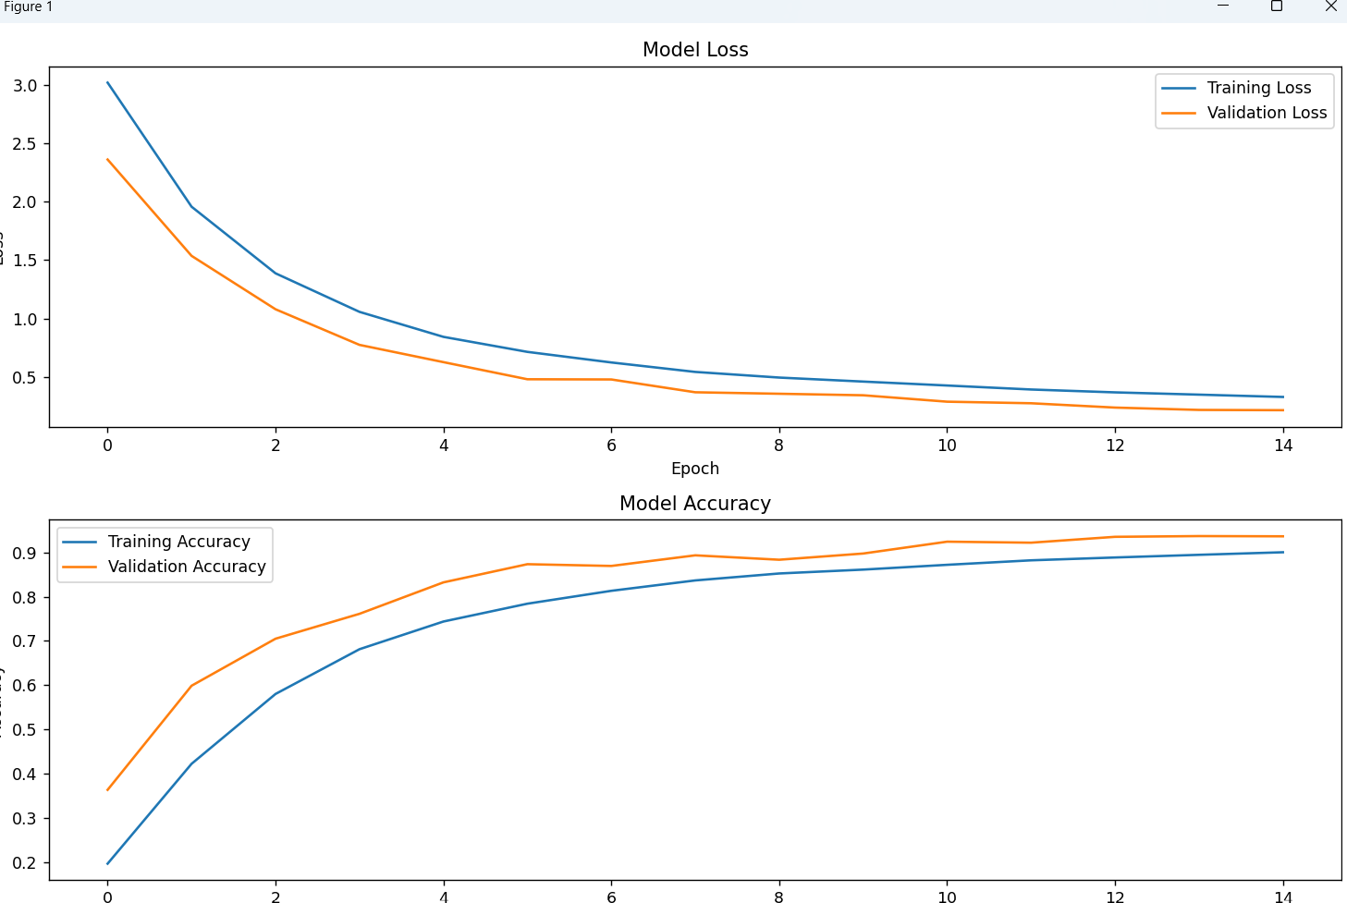

Realiai nuo 10 epochos nedaug kas gereja, arteja train su validation duomenimis tik

Epoch 15/15

981/981 ━━━━━━━━━━━━━━━━━━━━ 30s 31ms/step - accuracy: 0.9022 - loss: 0.3302 - val_accuracy: 0.9505 - val_loss: 0.1794 - learning_rate: 1.0000e-04

246/246 ━━━━━━━━━━━━━━━━━━━━ 2s 7ms/step - accuracy: 0.9566 - loss: 0.1682

Validation Loss: 0.17296454310417175

Validation Accuracy: 0.9542266726493835

Geri rezultatai, nera greitas apsimokinimas, bandysiu mazinti foto dydi per puse, dabar yra 10 epochu po 28 secundes, keista kad viena fdiena su tais paciais hyperparametrais 93, kita 95 procentai? Bandysiu sujungti random flipus, blurus, visas augmentacijas, ir 10 epochu, jei suletes, paliksiu viena is augmentaciju, ir sieksiu kuo greitesnio apsimokymo

Paliksim contrasta tik, dabar su 32 filtrais ir 10 epochu nekazkas, desim po 64 filtrus

Epoch 10/10

981/981 ━━━━━━━━━━━━━━━━━━━━ 15s 15ms/step - accuracy: 0.6208 - loss: 1.1930 - val_accuracy: 0.7886 - val_loss: 0.7494 - learning_rate: 5.0000e-04

246/246 ━━━━━━━━━━━━━━━━━━━━ 1s 4ms/step - accuracy: 0.7878 - loss: 0.7547

Validation Loss: 0.749366283416748

Validation Accuracy: 0.788601279258728

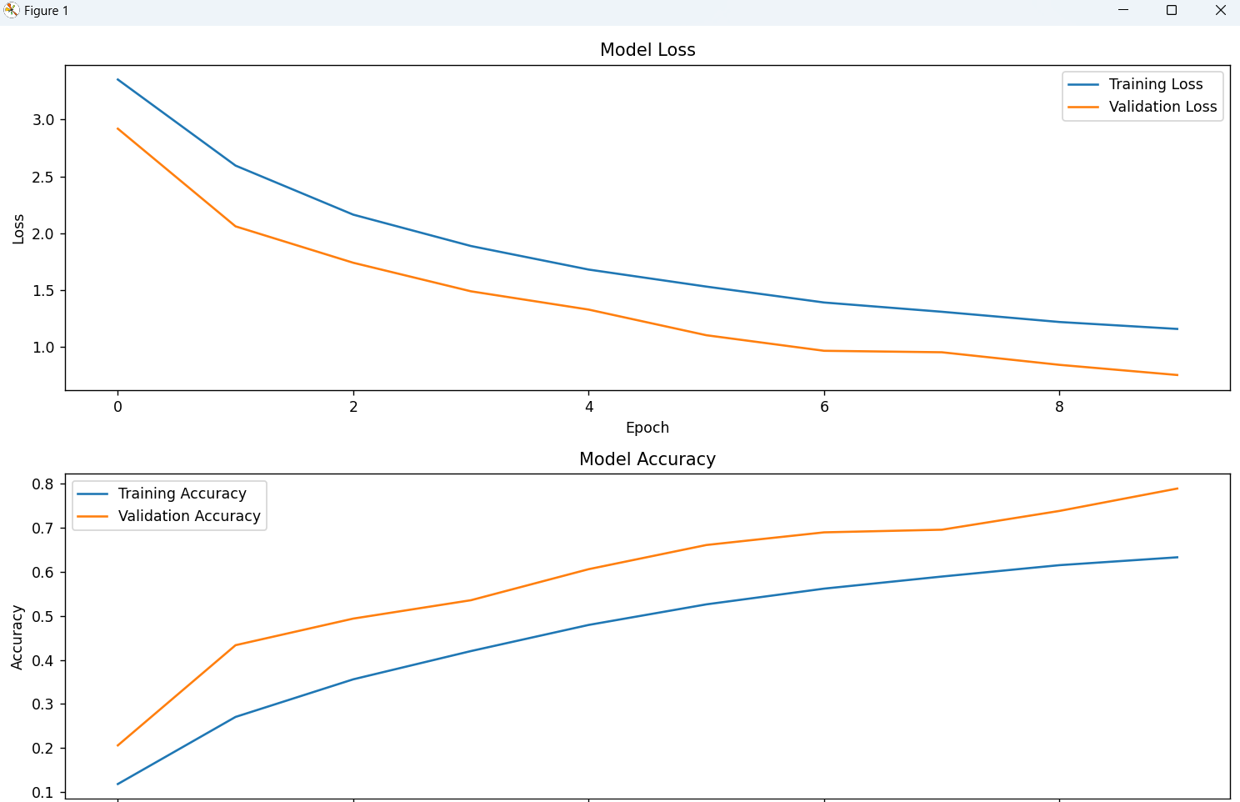

Su 64x64

Epoch 10/10

981/981 ━━━━━━━━━━━━━━━━━━━━ 41s 29ms/step - accuracy: 0.8599 - loss: 0.4649 - val_accuracy: 0.9360 - val_loss: 0.2343 - learning_rate: 1.0000e-04

246/246 ━━━━━━━━━━━━━━━━━━━━ 2s 7ms/step - accuracy: 0.9379 - loss: 0.2347

Validation Loss: 0.234283447265625

Validation Accuracy: 0.9359938502311707

Dabar vietoj 64x64 filtra keisiu I 128x128, ir learning rate pamazinsiu 0.001

Epoch 10/10

981/981 ━━━━━━━━━━━━━━━━━━━━ 69s 70ms/step - accuracy: 0.9699 - loss: 0.1040 - val_accuracy: 0.9883 - val_loss: 0.0474 - learning_rate: 2.0000e-04

246/246 ━━━━━━━━━━━━━━━━━━━━ 4s 16ms/step - accuracy: 0.9888 - loss: 0.0474

Validation Loss: 0.04740125685930252

Validation Accuracy: 0.9882698059082031

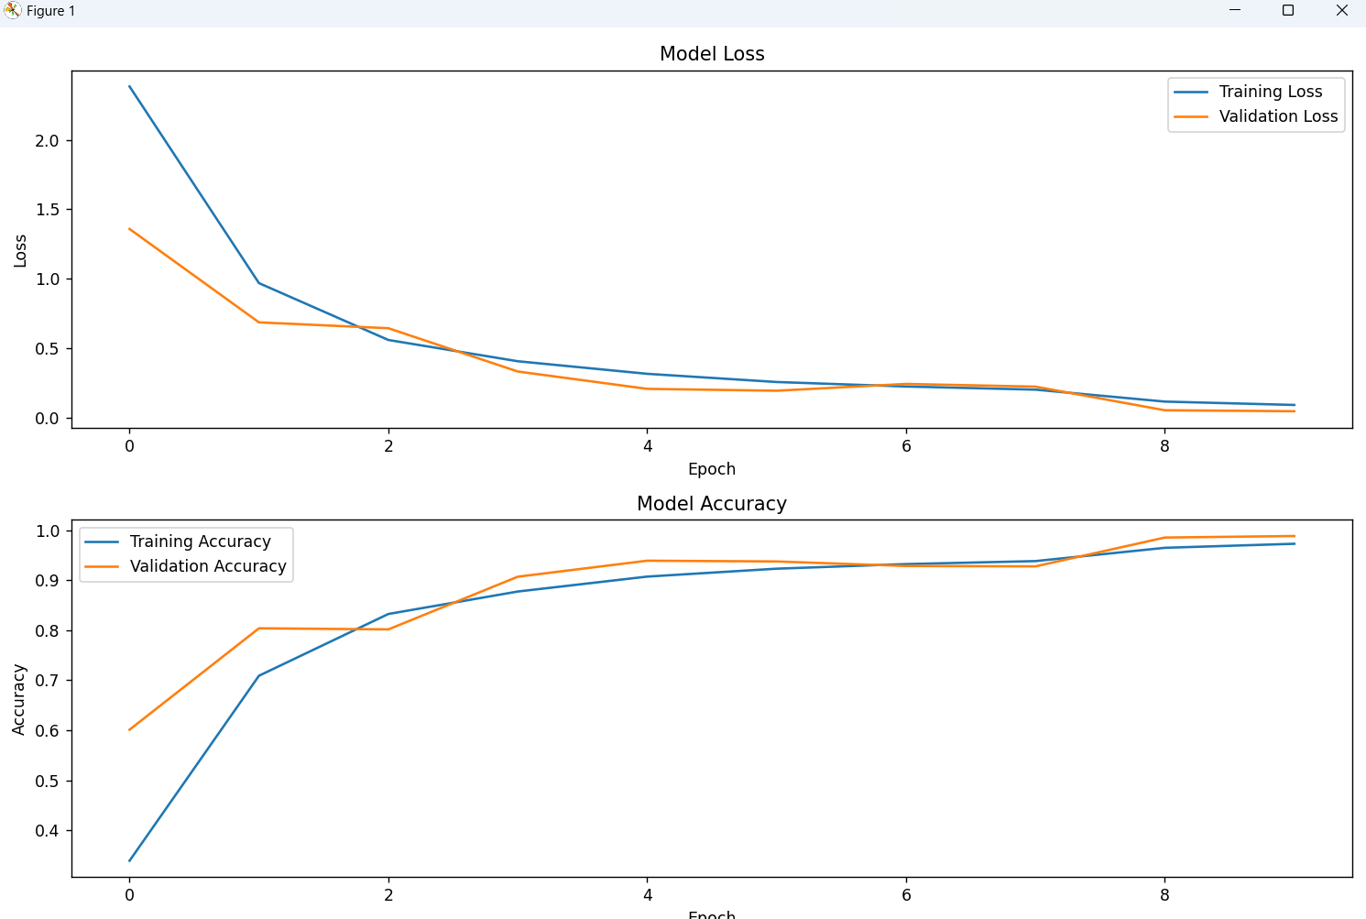

Labai nice, ties 4-5 epocha gaunasi geri rezultatai, bet epocha uztrunka 1min, ties 8 epochu isijunge lrreduce, pagerejo dar labiau, bandysiu 128-64-32 filtrus padaryti

Epoch 10/10

981/981 ━━━━━━━━━━━━━━━━━━━━ 52s 53ms/step - accuracy: 0.7671 - loss: 0.7268 - val_accuracy: 0.9035 - val_loss: 0.3537 - learning_rate: 0.0010

246/246 ━━━━━━━━━━━━━━━━━━━━ 3s 12ms/step - accuracy: 0.9054 - loss: 0.3500

Validation Loss: 0.3537236452102661

Validation Accuracy: 0.9034808278083801

Nepasiteisino, bandau sugraziniti visus I 128x128,, paleisti I 5 epochas, learning rate padiidnti, ir patestuosiu kaip gausis

81/981 ━━━━━━━━━━━━━━━━━━━━ 66s 67ms/step - accuracy: 0.8340 - loss: 0.5361 - val_accuracy: 0.8841 - val_loss: 0.3754 - learning_rate: 0.0050

246/246 ━━━━━━━━━━━━━━━━━━━━ 4s 15ms/step - accuracy: 0.8843 - loss: 0.3778

Validation Loss: 0.3753935396671295

Validation Accuracy: 0.8841004967689514

Su pakeistu learning rate

981/981 ━━━━━━━━━━━━━━━━━━━━ 71s 72ms/step - accuracy: 0.8975 - loss: 0.3401 - val_accuracy: 0.9420 - val_loss: 0.1999 - learning_rate: 0.0010

246/246 ━━━━━━━━━━━━━━━━━━━━ 4s 16ms/step - accuracy: 0.9404 - loss: 0.2040

Validation Loss: 0.19993789494037628

Validation Accuracy: 0.9419865012168884

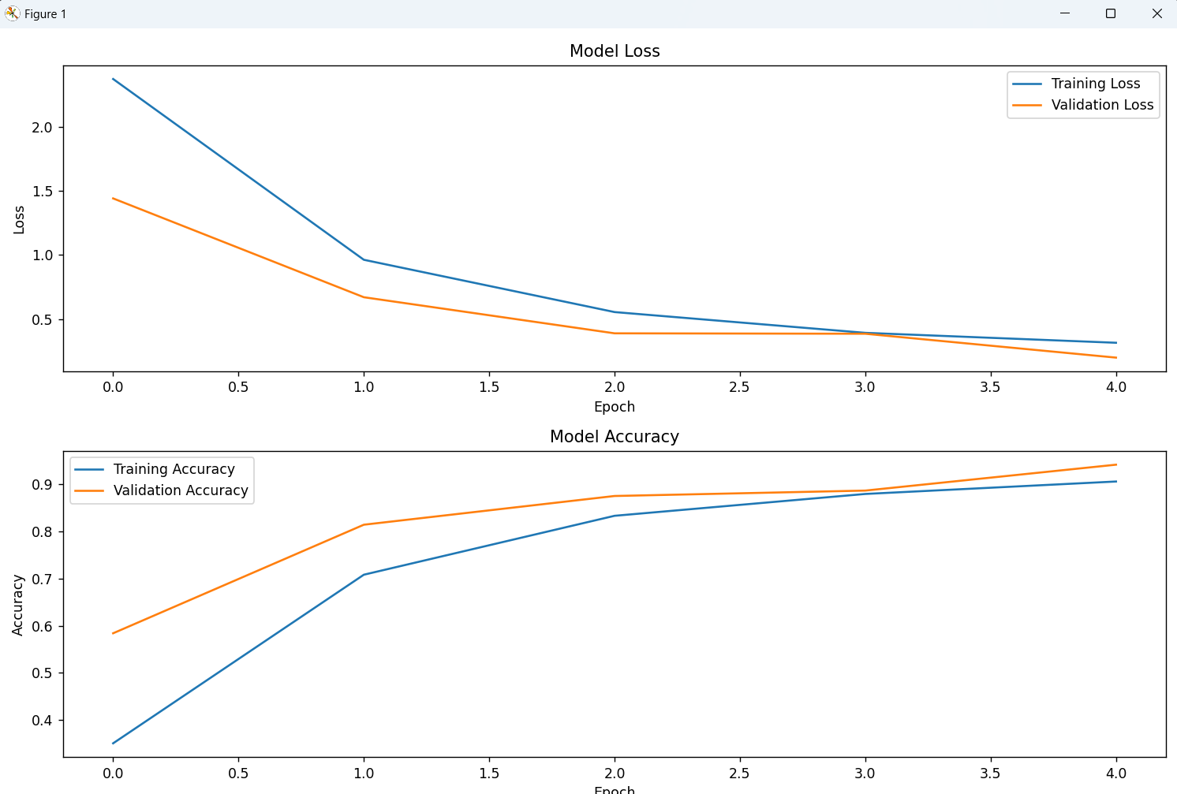

Paleisiu ta paty, tik filtru po 64 64 32 padarysiu

Epoch 10/10

981/981 ━━━━━━━━━━━━━━━━━━━━ 27s 27ms/step - accuracy: 0.7544 - loss: 0.7588 - val_accuracy: 0.7303 - val_loss: 0.9725 - learning_rate: 0.0010

246/246 ━━━━━━━━━━━━━━━━━━━━ 2s 7ms/step - accuracy: 0.8668 - loss: 0.4328

Validation Loss: 0.4381851255893707

Validation Accuracy: 0.8670151829719543

learning_rate=0.0005

64 64 64 filtrai, manau gerai, 10 epochu po 25-30 sekundziu

Epoch 10/10

981/981 ━━━━━━━━━━━━━━━━━━━━ 28s 29ms/step - accuracy: 0.8662 - loss: 0.4505 - val_accuracy: 0.9055 - val_loss: 0.3235 - learning_rate: 5.0000e-04

246/246 ━━━━━━━━━━━━━━━━━━━━ 2s 6ms/step - accuracy: 0.9073 - loss: 0.3241

Validation Loss: 0.323452353477478

Validation Accuracy: 0.9055208563804626

Conclusion:

Galime Daryti maziau epochu, daugiau filtru, mazesnis learning rate, gausime toki pat tiksluma per panasu laika kai padarydami daugiau epochu, maziau filtru, mazesniu learning rate.

Resnet nepavyko padaryti, neuzkraudavo Kompas, augmentacijos taip pat smarkiai pailgindavo mokymasi, o tikslumas mazedavo, turbot reiketu daaaugiau laiko, bet sumazintume overfitinima.

Random forest bandziau suu HOG ir be jo, Be HOG tikslumas buvo 96%, su HOG mazesnis, bet del idomumo palikau ji modelyje.

Geriausias rezultatas CNN gavosi 98.8% accuracy ant val datos, loss 0.047, cia buvo su 128x128 foto visur, ir learning rate 0.001, augmentation tik random flip, bet mokinosi ilgokai

Paleistas kodas ant situ rezultatu:

Epoch 15/15

981/981 ━━━━━━━━━━━━━━━━━━━━ 25s 25ms/step - accuracy: 0.9157 - loss: 0.2779 - val_accuracy: 0.9616 - val_loss: 0.1456 - learning_rate: 1.0000e-04

246/246 ━━━━━━━━━━━━━━━━━━━━ 1s 6ms/step - accuracy: 0.9628 - loss: 0.1421

Validation Loss: 0.14562760293483734

Validation Accuracy: 0.9616169333457947

